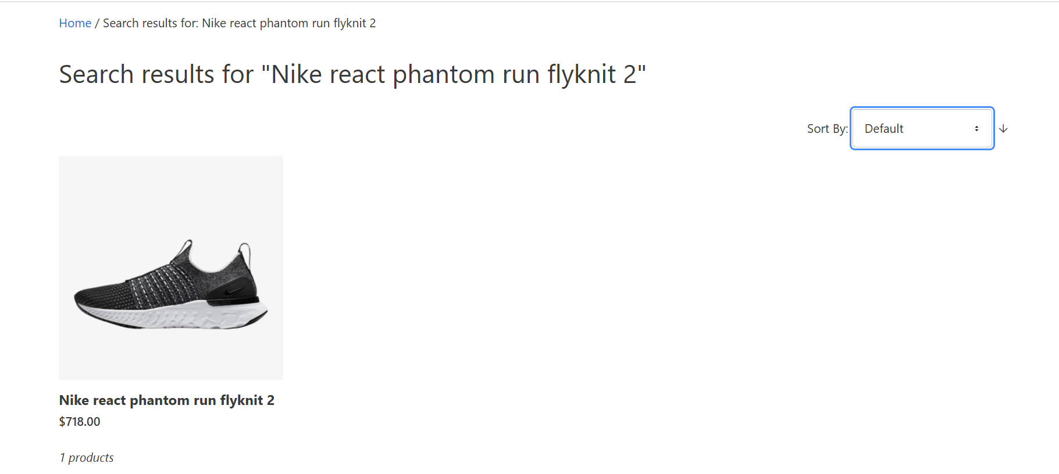

Test Id 7: search result page is not showing all the information except price.